200200800 - Reconnect Kootenai River with the historic floodplain
Sponsor: Kootenai Tribe of Idaho
Budgets: FY07: $241,500 | FY08: $512,000 | FY09: $551,500
Short description: Investigate and implement actions to reconnect the Kootenai River with its historic floodplain. Project objectives are based on ecosystem restoration principles consistent with the subbasin plan, Biological opinion, and White Sturgeon recovery plan.
view full proposal

Recommendation: Fundable in part

Comment:
Past ISRP comments were that this is a high priority effort, in principle at least, but there were lots of weaknesses and evidence of areas of concern in the earlier proposal. All that seems to hold true now and the red flags are still waving.
The proposal provides a fair write-up of the general aspects of the current feasibility study, but it raises more questions than it answers. The hypothesis guiding this effort is a belief that they can take what is available in the target reach and increase its productivity for fish and wildlife (in a cost effective manner and with the limitations imposed by no new water, adjacent private land ownership, and existing/past management). Progress to date includes a conclusion that what they propose is feasible, but they have not made a convincing case that the cost-effectiveness component of their hypothesis is feasible or reasonable. The arrangements for one creek fell through, and they won't be using the same location for proposed work. But the planning experience will be used at another site. Use of the new site is assumed for the proposal, although much arranging still needs to be done.
This is not fully supportable at this point. The narrative is incomplete and contains many redundancies. There is only sketchy budget itemization and individual personnel responsibilities are unclear. Credentials of the sponsors are impressive, but several fluvial geomorphologists should review a completed proposal before it is approved.
Sponsors assume that the preferred alternative will be constructed, but it is clear that this would be a compromise on channel length, with restoration of the original not being feasible. Are there any suitable alternatives?
Sponsors should provide an assessment of ecosystem "productivity" that presently exists and provide estimates of the benefits expected from their proposal along with the projected cost. Sponsors cite references that passive restoration may take decades or centuries once a change is in place, but an explanation of basis for their conclusion that it can be accomplished in less time should be included.
A complete proposal will show clear evidence of real community buy-in. The Nature Conservancy is always deeply involved with anything on its property but they are hardly mentioned here. Is there any cost-share with the Nature Conservancy or others? An M&E section needs to be developed and included in the proposal.
This project may have some potential for producing desired benefits, but a cautious approach is needed. The proposal is really not much farther along toward implementation than was the previous one. The implementation objectives are not justified at this time. There is no water to restore the historical floodplain, suggesting they should focus on areas where they can get water.
The project is fundable to complete the design.

Kootenai Tribe of Idaho (KTOI) Response to ISRP Comments (Project # 2002-008-00)

ISRP Comment #1: Several times, ISRP raises the concern that the project proponents have not made a convincing case related to the “projected costs” and “cost-effectiveness” of project 2002-008-00.

Project Proponent Response to #1:
The primary rationale behind the 2002-008-00 hypothesis is to assess the feasibility of restoring ecological components to the Kootenai River floodplain. Along with this feasibility study, the project intensions are to examine the costs of restoring ecological functions and address as many limiting factors as possible under the development of alternatives.

As proposed under EPA Ecological Restoration (EPA 841-F-95-007; November 1995), we proposed to use a basic economic approach; “cost-effectiveness analysis - used to compare two or more alternatives that achieve the same objective and can also be used to evaluate whether benefits are commensurate with costs… The most cost-effective restoration technique either (a) achieves the resource objective at the lowest cost (cost minimization) or (b) produces the greatest benefits for the same cost (benefit maximization).” From the project proponent perspective, the cost-effectiveness of restoration projects of this nature should strive to provide the greatest cost to benefit ratio, cost-per-unit, and/or net value while understanding uncertainties (cost categories, cost distribution, timing), and determining the benefits (prioritized, quantifiable and monetary benefits). We recognize and will address the difficulties and shortfalls when assessing cost-effectiveness, where EPA stresses the need for clear objectives, that cost-effectiveness is relative and can change under various situations.

“Some problems cannot be reduced through any reasonable degree of restoration. In summary, evaluating the cost effectiveness of restoration techniques requires considerable preparation, including the following:
- Identifying objectives;
- Understanding how well each alternative achieves objectives and creates benefits;
- Understanding costs of alternatives for achieving objectives;
- Estimating prioritized, quantifiable, or monetary benefits obtained from each alternative;
- Estimating the value of the range of benefits created by each alternative;
- Understanding the appropriate scale of the analysis; and
- Selecting the method for comparing costs and benefits of alternatives.”
(EPA 841-F-95-007; November 1995)

Ecological Restoration - EPA 841-F-95-007 (November 1995)

http://www.epa.gov/owow/nps/Ecology/

ISRP Comment #2: ISRP commented that “The hypothesis guiding this effort is a belief that they can take what is available in the target reach and increase its productivity for fish and wildlife…with the limitations imposed by no new water…There is no water to restore the historical floodplain, suggesting they should focus on areas where they can get water.”

Project Proponent Response to #2:
Yes, the hypothesis was correctly interpreted by the ISRP, but there is a misunderstanding regarding the project analysis of “water” and potential use of “new water”. We want to take this opportunity to clarify that water is the most significant limiting factor on the Kootenai River floodplain because it is either precluded from it by hydroelectric dam operation and/or levee construction or rapidly drained from it by stream diversions, ditches, and drain-tiles. In the feasibility analysis it is clear that water is available for floodplain habitats but instead of being utilized it is removed to accommodate agriculture production. In a simplified description we propose to shift floodplain water management from the current priority (drainage) to an ecological storage design (streams, riparian, wetlands, sloughs). To accomplish it is necessary to made landscape adjustments such as stream realignment, wetland creation, riparian restoration, and reconnection with the Kootenai River.

As restoration project, founded with ecosystem principles, our focus begins with nutrient cycles and lower trophic levels. Our results show that Total Phosphorus (TP) occurs at mean concentrations of approximately nine times that of the mainstem river. What’s more, the mean concentration of Soluble Reactive Phosphorus (SRP), the form of phosphorus most usable by primary producing organisms, occurs in floodplain habitats at least one order-of-magnitude higher than mainstem habitats. Resulting primary production response, in the floodplain is in excess of five times that of the mainstem river. That value would likely be significantly higher if aquatic macrophytes were added into the chlorophyll-a analysis. And, while productivity in the mainstem river has been shown to be limited primarily by phosphorus, floodplain habitats generally appear to be limited by factors other than nutrient concentrations.

We are not suggesting that implementing this project will result in a significant trophic index change in the mainstem river, which has been shown to be hyper-oligotrophic (Holderman and Hardy 2004). Additionally, as more projects like this are implemented, more synergies will be realized throughout the watershed.

ISRP Comment #3: “There is only sketchy budget itemization and individual personnel responsibilities are unclear…several fluvial geomorphologists should review a completed proposal before it is approved.”

Project Proponent Response to #3:
Multiple disciplines are working on the project design, implementation, and monitoring. The major disciplines include fish/wildlife ecology, hydrology, river engineering, fluvial geomorphology, and hydrogeology. Below are descriptions of the involvement each discipline will have on the project.

Fish/Wildlife Ecology:
The ecologists working on this project will coordinate with other disciplines to create a condition most suitable for the native community and by monitoring trophic levels from primary producers on up, ecologists can apply statistical measures to determine the local effects of the project and estimate its relative contribution to higher, more visible, trophic levels.

The focus of this work is to increase the sustainability of native species. This effort is not focused on a single species, but the entire native community where recreating floodplain ecology, to the extent feasible, the physical condition and function of the floodplain will result in community level biological response.

Large river floodplain restoration is still in its infancy and throughout this project we expect to document ecological benefits directly attributable to project actions and learn from the process so the cost/benefit ratio is reduced. In the end, the ecologist’s role is to define successful outcomes of the project, design an environment (locally) that will result in project success, monitor trophic levels and productivity, and evaluate success based on results.

Jason Scott: Professional biologist with GeoEngineers, Inc.
Scott Soults: Professional Wildlife Biologist with the Kootenai Tribe of Idaho
Beth Chase: Professional Ecologist with the Kootenai Tribe of Idaho

Hydrology
The project hydrologist is responsible for determining the duration and extent of flooding from the Kootenai River, Ball Creek, and a combination of the two. Methods include utilizing bathymetric and topographic maps in concert with modeling programs such as HEC-RAS, HEC-GeoRAS, and River 2D. The hydrologist will also be responsible for assisting with developing the restored alignment of Ball Creek.

Since the natural floodplain ecology in the area was dominated by surface water conditions and is presently drained of almost all surface water, a professional with expertise in hydrology is part of our team. To complete the design it is necessary that we know and understand what water is available within the project area and its timing. Water sources include localized runoff events, Ball Creek flows, and Kootenai River flows.

Jon Ambrose: Professional hydrologist with GeoEngineers, Inc.

River Engineer:
The project engineers are responsible for integrating results and analyses from the other disciplines and preparing design plans suitable for guiding construction efforts. The design plans will be complete with multiple views, call-outs, specifications, materials, construction sequencing, appropriate Best Management Practices (BMP) to be followed through construction, and cost estimates. Final products will be scrutinized by an engineer licensed in the State of Idaho.

Michael Homza: Civil engineer and hydrologist with GeoEngineers, Inc.

Klaus Jorde: Professor of Civil Engineering, Ecohydraulics Research Group, Univ.of Idaho

Hydrogeology:
The project hydrogeologist is responsible for estimating groundwater flow volume and direction, determining storage capacity, and estimating the relative hyporheic contribution to be expected from tributary re-alignment and to the Kootenai River proper. The project hydrogeologist will use well-log information, piezometer data, and model output to help determine the optimal locations for Ball Creek and help develop expectations for the project relative to the groundwater’s ecological contribution.

Ground water and hyporheic interaction are often overlooked as contributors to ecosystem function. However, within the floodplain, groundwater contributes to ecosystem function. We hypothesize that elevation of the groundwater surface will increase by allowing surface water to inundate the project area regularly. The increase in elevation directly correlates with increasing groundwater storage volume, which will enhance wetland and riparian vegetation and have an added value by increasing reservoir size and potentially contributing to attenuation of flood flows.

Jon Rudders: Licensed Geologist and Certified Hydrogeologist with GeoEngineers, Inc.

Fluvial Geomorphology:
The fluvial geomorphologist will evaluate the physical and geological conditions of the local area and analyze the local hydrology to help shape and re-align the Ball Creek channel so it appropriately transmits energy and sediment while providing habitat conditions.

Mary Ann Reinhart: Fluvial geomorphologist with GeoEngineers, Inc.
Several other fluvial geomorphologists will assist in project design and evaluations. Other may include, but not limited to: Jodie Lamb, L.G., John Ostendorff, Michel Ybarrando, P.E.

The lack of a budget itemization was an oversight by the author. The majority of the project is subcontracted to GeoEngineers, Inc, due to the large professional staffing needs presented by this project. In the 2007-2009 project proposal we stated that we will assess the costs and feasibility of restoration alternatives and the project sponsors will submit detailed itemizations of budgets and work in the BPA format (Work Elements). Each work element (objective) has associated milestones (tasks) that detail project work. Once the feasibility and alternatives are developed (50% design), we will be able to produce the similar work/budget itemization as shown in Table 1.

Work Element Tasks | Senior Principal | Senior Hydrogeologist | Proj. 2 Fish Biologist | Staff 2 Geologist | Technician | Support
Project Management | 4 | 36 | 8 |  |  | 20
Hydrogeologic Review |  | 12
Gage Installation
Monitoring Well and Gage Instrumentation |  | 4 |  |  | 12
Soil Testing |  |  |  |  | 8
Slug Testing-Field |  | 20
Slug Testing-Analysis |  | 16
Groundwater Monitoring |  | 24 |  |  | 75
Data Reduction/Analysis |  | 16 |  | 8 |  | 4
Groundwater Modeling |  | 80
Meetings |  | 8
Report Writing | 4 | 32 | 8 |  |  | 16
Subtotal | 8 | 248 | 16 | 8 | 95 | 40
Total Hours | 8 | 248 | 16 | 8 | 95 | 40

Table 1. Work Element 118 – Groundwater Monitoring Cost Estimate and Budget Itemization.

ISRP Comment #4: “Sponsors assume that the preferred alternative will be constructed, but it is clear that this would be a compromise on channel length, with restoration of the original not being feasible. Are there any suitable alternatives?”

Project Proponent Response to #4:
The construction of the preferred alternative will not compromise channel length. After reviewing our proposal we acknowledge that our description of the current condition lacks clarity. Other than the channel which Ball Creek currently flows, the historic channel no longer exists and is just part of the crop producing fields. Evidence of a historic channel appear in aerial photographs, taken in the early spring prior to germination of spring crops, and topographic data illustrated in the DTM. These are not to be confused Kootenai River flood channels, which are clearly apparent in field observations, aerial photographs, and DEM. It is necessary to understand the current condition of the historic channel, or lack thereof, because there hasn’t been one to compromise since some time prior to 1928.

Since that time, in order to keep agricultural fields free from surface water, a drainage system has been developed. The cornerstone of that system is a deeply incised (about 20-30 feet) drainage ditch that flows from east to west and bisects the property. We explored an alternative where Ball Creek would cross that ditch but ultimately determined the cost to be too great for minimal ecological returns. Further, the risk associated with it could result in project failure and costly maintenance in the future. Other alternatives were explored and are possible but, through our alternative analysis we determined the suggested alignment provides the most benefit, ecologically and economically.

Considering that the 14,700 feet of proposed channel is currently managed as an agriculture field and the existing channel is more of a ditch than stream, it is our opinion that the project will result in a net gain of 14,700 feet of high-quality stream habitat, associated riparian area, and connected wetlands.

ISRP Comment #5: “Sponsors should provide an assessment of ecosystem "productivity" that presently exists and provide estimates of the benefits expected from their proposal…”

Project Proponent Response to #5:
The Kootenai River ecosystem has been severely degraded over the last 100 years due to hydroelectric development and poor land and resource management practices. Declining populations of native fish and wildlife species resulting from decades of ecological degradation are being realized at an alarming rate. Causes of habitat degradation are numerous and the effects cross many species/community boundaries. Therefore, single species restoration simply is not an effective means of restoration. We recognize that if a project was proposed to address a single species it would yield measurable results sooner than ecological restoration but it also might further throw the local ecology out of balance. This project clearly focuses on addressing the problem rather than the symptom.

Since 2001, ecological assessment report findings for the Kootenai River have been substantial (refer to literature cited section in BPA 07-09 project proposal #2002-011-00). We have documented wetland losses (Figure1), Tributary losses–“Stream intermittent natural” (Table 1 and Figure 2) and channelization (Figure 3), increase in drainage ditches (Table 1 and Figure 2), changes in aquatic trophic levels (BPA# 1994-049-00), endangered fish population (Kootenai White Sturgeon, and numerous associated riparian and aquatic losses across the basin.

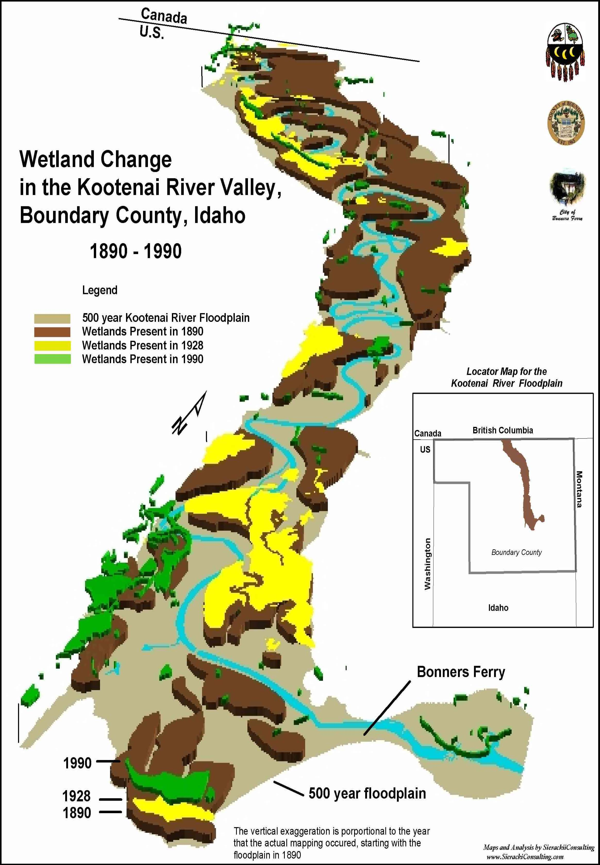
Figure 1. Wetland losses in the Lower Kootenai River floodplain from Bonners Ferry to the Canadian Border (from KTOI 2005).

TYPE | Function | Modified | 1928 | 1985
Ditch | Intermittent | manmade | 64.66 | 91.99
Ditch | Perennial | manmade | 7.81 | 51.75
 |  | Subtotal Ditches | 72.47 | 143.74
Stream | Intermittent | modified natural | 50.49 | 77.66
Stream | Intermittent | natural | 24.67 | 5.6
 |  | Subtotal Intermittent Streams | 75.16 | 83.26
Stream | Perennial | modified natural | 20.01 | 23.02
Stream | Perennial | natural | 14.53 | 15.29
 |  | Subtotal Perennial Streams | 34.54 | 38.31
 |  | Total Stream Length | 109.7 | 121.57
All | All | Waterway Miles | 182.17 | 265.31
Table 1. Change in waterway miles from 1928 to present.

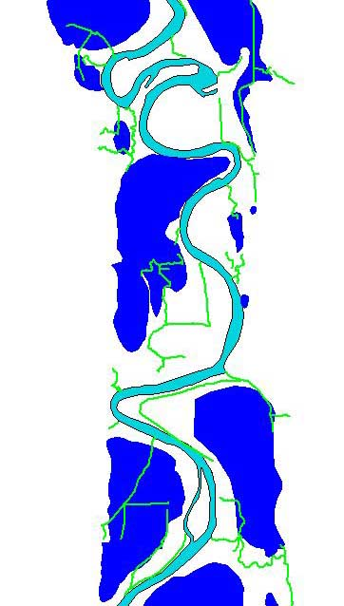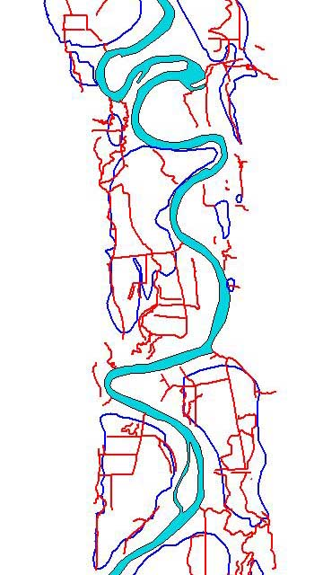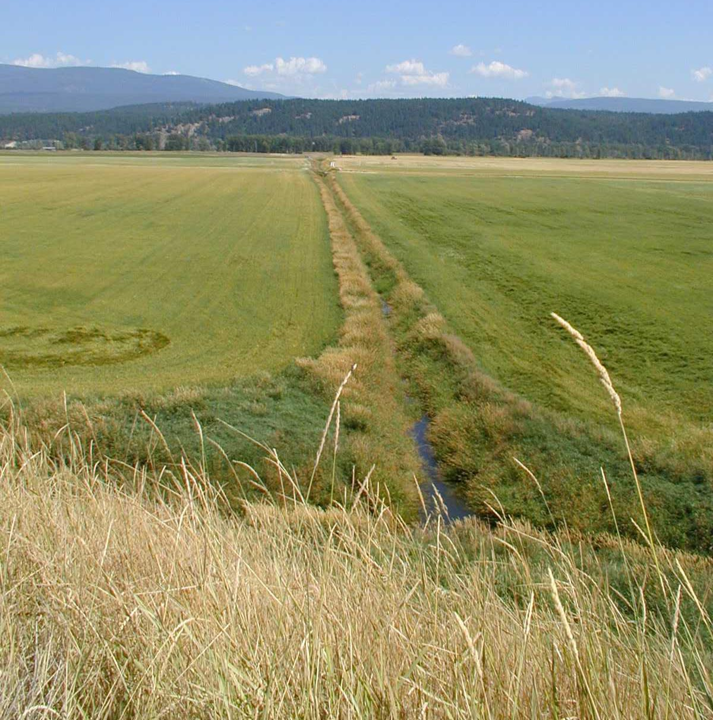
Figure 2. Floodplain waterway change from 1890 to present. Figure 3. waterway channelization.

Measurable objectives are being developed and described by project 2002-011-00 (refer to M&E objectives), and the project sponsors will integrate these into future project objectives to assess restoration activities. Finally, the sponsors will work with the local community for input to reasonable solutions for restoration activities in the Kootenai River Valley while co-existing with economic and social interests of the area.

As the “Reconnect Kootenai River with the historic floodplain” (BPA #2002-008-00) project states, this…“is a beginning to restoring natural ecosystem processes in the Kootenai River Basin by creating physical habitat for native aquatic and terrestrial wildlife as well as the botanical community. Further, as an ecosystem restoration project, it also addresses nutrient cycles, assimilation, and the trophic cascade which has been interrupted. It is not intended that implementing this project alone will lead to full species recovery but it is one element of an overall program addressing single species problems with ecosystem level restoration approaches.”

ISRP Comment #6: “Sponsors cite references that passive restoration may take decades or centuries once a change is in place, but an explanation of basis for their conclusion that it can be accomplished in less time should be included.”

Project Proponent Response to #6:
Over time, natural alluvial systems attain a degree of balance between seemingly opposing forces. For example; the rate at which a stream’s left bank erodes eventually becomes equal to the rate at which a gravel bar develops along its right bank due to deposition and vegetation growth. Such systems in balance are said to be in “dynamic equilibrium” (Rosgen, 1996). Left to its own devices (e.g., without human intervention such as the continued levee maintenance and dam operations), a disturbed system will naturally tend back towards dynamic equilibrium. Depending upon the system, this can take from decades to centuries.
Our design approach is targeted at fast-forwarding these natural self-healing geomorphic processes. For example; the channelized condition that Ball Creek currently occupies is forced to adjust vertically because the channel is maintained to stay confined. Consequently, the channel continues to incise, whereas the natural channel adjusted horizontally.
If we were to simply stop maintaining the channel and levees, the channel would eventually re-adjust to another alignment and ultimately tend back toward a meandering channel with an in-tact riparian area and functional floodplain. The trouble with proceeding with that process is, since perturbations are so extensive, the natural “healing process” or “passive restoration” is likely to take centuries. However, if we use this opportunity to construct a new channel we expedite the restoration process by hundreds of years.
Likewise, restoring the entire project area to its natural condition, immediately, is not practical, feasible, or cost effective. For instance, after construction our plans will include a re-vegetation plan that will place trees and shrubs in a wider spacing and utilize passive restoration techniques to fill in the gaps, and understanding most of the plants will be many years from maturity. In that sense we will have to rely on passive restoration which includes removal of the original problem allowing the native community to rebound. Of course, maintenance will be required throughout the early successional stages to minimize non-native invasions. Perhaps, in 10 to 20 years or so the riparian community will be in-tact and functionally provide stream shade and bank stabilizing networks of maturing woody plants but succession is an ongoing and passive process.
This concept is similar for wetlands and sloughs in the floodplain. In all likelihood, at some point in the future, if levees are not maintained and large flood flows are experienced from the Kootenai River, floodplain habitats will reestablish. Waiting for and depending on such evens is unreasonable, but could be interpreted as a drawn out passive restoration activity. We can expedite that by sculpting the floodplain, breeching the levee to allow Kootenai River flood water to inundate the floodplain, and allowing Ball Creek water to be used as a surrogate for Kootenai River water when mainstem flows are not sufficient to inundate the floodplain. Therefore if we intervene, we can accomplish in a few years, on a local scale, something that would take centuries to occur passively. And, at the rate species are declining, waiting will likely result in extinctions.
ISRP Comment #7: “Is there any cost-share with the Nature Conservancy or others?”

Project Proponent Response to #7:
Yes, The Nature Conservancy (TNC) is supportive of the project and willing to donate productive farm areas to help restore their land. The land is currently being leased so this project would eliminate this income. It is possible that yields in adjacent fields will increase with the potential raising of the ground water table but that is not certain or even expected. We have not asked TNC or others to include restoration dollars at this point since we do not have a proposed design.

ISRP Comment #8: “An M&E section needs to be developed and included in the proposal”

Project Proponent Response to #8:
The following are M&E objectives (BPA Work Elements) in 2002-011-00 that are correlated, and were designed in association with project 2002-008-00 objectives:

WE1a (Work Element) - RM&E and Data Management: Collect/Generate/Validate Field and Lab Data

1a1: Distinguish geomorphological reaches of the Kootenai River (canyon, braided, meandering) in terms of potential productivity limitation (changes in habitat type and recruitment) and biological productivity status (habitat types/NPP).

Overview:
Ball Creek Ranch will be assessed along the same lines as other habitats in the Kootenai River floodplain – Kootenai River Floodplain Operational Loss Assessment (#2002-011-00). Currently, the majority of the Ball Creek Ranch is under agricultural production (wheat/canola dependent on rotations), where grazing and hay production are primarily found around the perimeter due to watering site (river/ditch water). Ball Creek Ranch has linear remnants of cottonwood galleries along the river depositional areas (currently being assessment by project #2002-011-00), but most cottonwoods have been removed/cleared for agricultural/grazing and/or dikes. Current assessments follow 2002-011-00 RM&E outline: Mixed pixels cause errors estimating VI (Vegetation Index) and NPP from satellites when used in riparian/floodplain systems with relatively small or linear features. The grain (pixel size) of the data utilized in analysis should be scaled to adequately represent the size of the landscape element being classified, or of high enough resolution to allow for more accurate derivation of VI. Fox et al. (2002) determined wildlife habitat could be successfully classified with more detail using pan sharpened LANDSAT imagery (15m cell). Thirty meter derived VI values would be split into 4 smaller pixels but they would still be mixed. The dilution of VI from pixels overlapping different habitat types would still occur. The 30 m grain may be adequate for habitat classification and VI for wide valleys and large rivers such as in the meander and parts of the braided reaches; however initial results indicate that this pixel size may be inadequate for the canyon reaches of the Kootenai River, where the outer edge of the 500 year floodplain may be very close to the water’s edge. Thirty two 9 cell plots, located in the canyon reaches, representing a 50m plot radii, had the majority habitat component as water. The narrow linear features in this section caused some of the misclassification due to mixed pixels. The issue of scale also influences landscape metrics. Landscape metrics vary with changing grain sizes. Comparing differences along a gradient from SPOT (20m) to AVHRR (1100m) data, Benson et al (1995) found that patch number decreased but detectable average patch size increased as a function of increasing satellite cell size.

Methods:
We propose utilization of finer grain satellite imagery such as Spot 5, QuickBird and investigate the hyperspectral imagery that is available through previous LiDAR data acquisition. The finer grain imagery would enable more accurate classification of habitats and smaller patch sizes. This will enable us to re-classify areas (typically canyon and braided reaches) with narrow, linear riparian habitats (currently under-represented Needleleaf Dominated Riparian (NDR), Broadleaf Dominated Riparian (BDR), Mixed Riparian (MR)) that were classified as “watershallow” with present larger grain imagery. With additional detailed vegetation information, these plots could serve as reference points for image classification. We hope to use the derived spectral signatures of wildlife habitat types for further extrapolation throughout the study areas. A 100m wide circular plot (7850m²) is represented by 9 LANDSAT pixels, 314 5m Spot 5 pixels and by 1256 pixels using 2.5m Spot 5 pixels. We will use the reclassification to re-analyze NPP on habitat types in the braided, and produce more concise NPP descriptions in the canyon and analogue site (Columbia wetlands and sectios of the Flathead River) as done in other reaches (also correlated to Objective 3b1). This analysis will be important for interpreting bird and invertebrate proportions related to IndVal’s and correlation analysis (refer to Objective 4).

WE1b - RM&E and Data Management: Analyze/Interpret Data

1b1: Analyze and refine invertebrate and avian guild community categories to characterize trophic level linkage dynamics to estimate possible responses to experiment restoration activities.

Overview:
Ball Creek Ranch has six point-count sites (both bird and invertebrate samples) for habitat, avian and invertebrate community classification categories. We anticipate in adding point-count sites to restoration areas as the 50% design gets closer to completion. Again, we will utilize 2002-011-00 protocols, RM&E designs as basic methodologies to monitor and evaluate restoration activities in the Ball Creek Ranch. The ability to assess status and trends in the condition of ecosystems over broad geographic regions can allow identification of existing or developing problems prior to a crisis. Species have been proposed as environmental indicators under the assumption that the responses of individual species are representative of the responses of other species within a habitat or community. This indicator species concept has been criticized because individual species do not necessarily reflect trends in other co-occurring species (Morrison 1986; Landres et al. 1988). In fact, co-occurring species often differ in habitat requirements and life histories (Martin & Li 1992; Martin 1993, 1995), so individual species can be questionable indicators of community responses. Similar issues hold true for USFWS Habitat Suitability Index (HSI) methods where habitats are valued for individual species, and is currently used in the BPA Habitat Evaluation Procedure (HEP) program.

A more effective approach is to group like animals into guilds (Ehrlich, Dobson, & Wheye. 1998., Bailey et al.2004, Melles, Glenn & Martin. 2003) or some type of ecological hierarchy (Dale and Beyeler 2001, Andreasen et.al. 2001). These types of groupings can be useful for evaluating the overall responses of multiple species to changes in resources or ecological conditions that define the guild. The ecological integrity concept provides a system-specific framework in which species assemblage data can be ranked on a qualitative scale. This method of estimating condition can be more ecologically relevant than traditional analyses such as species richness and Shannon diversity (Blair 1996, Brooks et al. 1998).

Methods:
Refine avian and invertebrate guild community categories by utilizing expert peer-review, survey data, and statistical analysis (Objective 4) to define and link trophic level dynamics and interactions. We will utilize the refined information to construct ranking and IEI framework. We will prioritize the use of avian and invertebrate proportions and IndVal as described below (Objective 4a3, and described in Section E). In addition, we will use BIRDHAB, a GIS program, to assist in guilds and habitat types comparisons. During our Subbasin Plan assessments (Terrestrial Biome Assessment), we applied the Interactive Biodiversity Information System (IBIS) to investigate species with Key Ecological Functions (KEF) and Key Ecological Correlates (KEC). In our refinement of species/habitat relationships, we will make use of the IBIS “Habitat Value” method. The Habitat Value assesses different habitats using the hierarchical approach of cover (habitat) type, structural conditions, and KECs for each location (point-count site). The Habitat Value is calculated based on the potential of all fish and wildlife species that could use a site.

WE2b - RM&E and Data Management: Develop RM&E Methods and Designs

2b1: RDRT to develop an IEI ranking procedure and criteria for operational loss assessments and regional application

Methods:
Ecological Assessment of the Ball Creek Ranch will be accomplished within the bounds of the Kootenai River Floodplain Operational Loss Assessment (#2002-011-00). RDRT to develop and review an IEI ranking procedure, criteria and regional framework based on individual Indices of Biotic Integrity (IBI) and Index of Hydrologic Alteration (IHA) assessment methodologies and ecological attributes to interpret ecological change and loss. Framework will be developed in conjunction with regional elements (see WE 5a, 5b, 5c). Correlate geomorphological, hydrological, aquatic and terrestrial assessment factors in determining the final composition of the operational loss assessment tool. Criteria will be assessed from current IBI and IHA parameters and compared with regional methodologies (i.e., HGM, IBIS, EDT, HEP, HSI) for ease of use, consideration of crediting ledgers, contemplating out-of-basin issues, while working within the ecological province.

2b2: RDRT to develop adaptive management landform restoration experiments that are based on multi-trophic level attributes and IEI parameters.

Overview:

This objective under project 2002-011-00, clearly illustrates the ties between the 2002-008-00 and 2002-011-00. This objective, as stated, is to adaptively manage restoration experiments and monitor and evaluate ecological (IEI) parameters for “mitigation” purposes across the region, and find a better way to track ecological restoration then the current methodologies (i.e., HEP). The basic procedure developed in British Columbia for restoring large ecosystems is the Action Plan approach. This procedure is an extension of the Adaptive Environmental Assessment (AEA) workshop approach originally developed by Carl Walters and Buzz Holling in the 1970s to examine a variety of large-scale ecological issues. The essence of the AEA process is a series of interdisciplinary team workshops (i.e., RDRT) where simulation and empirical modeling are used to focus attention on the critical issue(s), identify data gaps, develop alternate hypothesis and develop testable hypothesis for adaptive management purposes. The approach explicitly assumes that ecosystems are too complex to fully understand, and that the best approach to learning ecosystem behavior is through adaptive management experiments in which the ecosystem is purposely perturbed in one way or another to test the validity of the underlying assumptions and explore the resulting ecosystem behavior. The Action Plan approach solves one of the major shortcomings of the AEA process: institutional resistance to implementing a long-term series of adaptive management experiments. All too often, once the initial workshops were completed, participants and/or agencies failed to implement the necessary experiments due to interagency rivalry, changing personnel, budget constraints, fading interest or an underlying distrust of the process (Walters 1997). The Action Plan format (in British Columbia) has managed to avoid these pitfalls by clearly identifying time lines, goals and responsibilities, core team membership and scheduling regular meetings. An important component of the Action Plan process has been the publication of an annual technical report and scheduling of public information sessions to present results and receive comments on the plan (e.g., IKERT and RDRT). Two additional key aspects of the Action Plan approach is the necessity to secure a multi-year budget, and to select core team members who will scientifically manage the program over long time periods. One of the largest impediments to ecosystem restoration is the time required to implement multi-year restoration programs. Institutional memory loss becomes a serious issue when restoration projects have multi-decadal time frames. Therefore, proper database management and core team successional planning is critical to maintaining long term momentum and following the agreed upon Action Plan.

Methods:
The RDRT, from project #2002-011-00, to review, develop and evaluate (M&E) adaptive management landform restoration experiments (i.e., #2002-008-00) that are based on multi-trophic level attributes and IEI parameters. RDRT has developed an Action Plan for project 2002-011-00 (2003 and 2004), but project specific restoration experiments (i.e., 2002-008-00) need further development of IEI ranking procedures, individual Indices of Biotic Integrity (IBI), Indices of Hydrologic Alteration (IHA) and related project activities (1994-049-00, 1988-064-00, 2002-002-00, 2002-008-00) have not been formally updated. RDRT is to revisit the Action Plan, incorporate related project activities (refer to WE-2a, and 2b, and Table 2 in section D), reflect current meeting plans (IKERT), and re-address adaptively managed long-term landform experiments in coordination with Project 2002-008-00. In this same process, we will work with regional Fish and Wildlife managers to address regional issues (Objective 5) associated with the finalization of an operations-based ecological assessment tool.

3a2: Utilize NDVI and habitat typing, avian & invertebrate surveys and hydrographic data to summarize values per unit area between Columbia Wetlands and Sections of the Flathead River as utilized in the assessment in the Kootenai River Floodplain.

Overview:
The primary goal of this pilot operational loss assessment and mitigation project is the assessment of losses of floodplain ecological functions and processes by comparing natural analogues in unregulated systems to the Kootenai River Watershed. Understanding the losses of functions and values, developing rehabilitation/restoration strategies (i.e., 2002-008-00) and biological potential of the Lower Kootenai River Watershed is critical for natural resource management efforts by the Tribal Fish and Wildlife Programs. The Columbia Wetlands and some sections of the Flathead River have been accepted by RDRT as adequate analogous sites for historic and current conditions of the meander, braided and canyon reaches of the Kootenai River. Utilization of analogue sites is crucial in the development of the operational loss assessment. Analogues can provide verification of historical and current NDVI, habitat typing, etc and values per unit area assembled, evaluated and forecast in the models and IBI/IEI’s.

Methods:
Survey methods used throughout this project (Section E) will be duplicated in analogue sites (in association with Objective 1, and coordination of Objective 2). Data collected by other personnel (e.g. Canadian FW authorities, Flathead Lake researchers) will be utilized if acceptable methods were used to collect data (e.g. standard BBS procedures).

WE4a - RM&E and Data Management: Analyze/Interpret Data (for 2002-011-00 assessments and relation to 2002-008-00 adaptive restoration experiments)

4a1: Evaluation of the Sampling Protocol

Methods:
This analysis encompasses a critical evaluation of the current sampling scheme employed by the Operational Loss Assessment (OLA) project, and adaptive restoration experiments (2002-008-00). The statistical analyses include determination of required sample sizes for various OLA trophic level data at different precision levels, along with statistical power analyses accounting for potential spatial and/or temporal variability and monitoring.

4a2: Average Response Analyses

Methods:
This will include conducting analysis of variance (ANOVA) and mean separation procedures to detect and examine potential average response differences for bird, invertebrate and vegetation metrics for the OLA project. The analyses will evaluate the effect of habitat groups on biotic (e.g. bird abundance) and abiotic (vegetation greenness measures) responses. This will help establish a possible framework for more sophisticated multivariate analyses and modeling efforts concerning various trophic level data.

4a3: Correlation/Regression Analyses

Methods:
We will conduct correlation (parametric and nonparametric) analyses of bird and invertebrate metrics such as specificity, diversity, and indicator value (McGoech, et al. 2002, Van Rensburg, et al. 1999) with those of habitat metrics, such as NDVI and Tassel cap in order to investigate any potential association structure. Regression models will be considered to relate bird ecological integrity to environmental variables. This technique will be useful to model the spatial dependence of the spatially structured relationship between the aforementioned variables (Van Rensburg, 2002).

4a4: Multivariate Analyses

Methods:
i) Computation of bird and invertebrate indicator values at various levels may be carried out based on cluster analyses as suggested by Dufrene and Legendere, 1997. This will enable selecting the optimal habitat classification and associated indicator characteristic and indicator detector species of birds and invertebrates for the OLA project. Cluster techniques may also be used to help construct a bird community-based measure of ecological integrity (Johnson, et al., 1998).

ii) Canonical correlation (correspondence) analyses (Hill and Gauch, 1980) may also be employed to identify the structure of bird /habitat data. Computation of correlation coefficients between avian species proportions and environmental correlates (Van Rensburg, et al. 2002) constitutes an important step towards understanding the underlying structure. However, we believe this structure to be multiplicative in nature. Hence, multivariate techniques such as biplot analysis (Bradu and Gabriel, 1978), with application to principle component analysis (Gabriel, 1971) could be used, as a multiplicative model, to diagnose and analyze the components of this two-way (bird/habitat) data structure (Shafii and Price, 1998). Canonical variables may then be identified to give better insights into understanding the ecological implications of the underlying correlation structure.

4a5: Additional Data-Based Analyses and monitoring

Methods:
i) Use empirical distribution of bird and invertebrate indicator values generated from the OLA project and data truncation techniques to identify percentile cutoffs and select indicator species. The results may be compared to the subjective bench-mark approach, as well as the selection based on various clustering algorithms.

ii) Refinement of existing OLA data through use of directional/distance information. This may enhance the habitat classification for each bird/invertebrate species/guild observation.

iii) Develop monitoring and survey methodology QC and QA.

4b1: Addition of all features and products currently implemented for the KTOI Ecosystem Relational Database (199404900 and 200201100 joint database)

Methods:
  - Incorporation of habitat level data (NDVI, Tassel Cap, Habitat Classifications)
  - Multiple (enhanced) graphing options
  - Download options for all specified output
  - Graphical display (matrix) of data availability
  - Creation/enhancement of trophic level data entry forms
  - Implementation of user data censoring option for each trophic level data
  - Addition of auxiliary trophic level information such as site characteristics, and ancillary data sets

WE5a - RM&E and Data Management: Disseminate Raw/Summary data and results

5a1: Disseminate data/information generated by BPA Project 200201100 to regional fish and wildlife managers, BPA, and other entities; provide writing assistance, review and editorial functions on project products.

Methods:
Project 2002-011-00 peer-review of project activities and results with the local and regional fish and wildlife managers will be accomplished through open forum meetings (i.e., CBFWA assist in facilitation). The results will be directly applicable to adaptive restoration experiments (i.e., 2002-008-00) and discussion will be held regionally. Through open meetings, both projects 2002-011-00 and 2002-008-00, we will implement informational meetings, presentations of IBI’s, IHA, and the framework behind IEI assessment tool. Present and submit publication of annual reports, methodologies, relational database data exchange, and document peer review comments and recommendations. The exchange of project information as well as consultation with other fish, wildlife, and land managers will help to ensure that project implementation activities are efficient and maximizing resource benefits in the most beneficial and cost effective manner. The sharing of data, implementation techniques and assessment and mitigation strategies with other managers will also promote a more consistent, cost effective, and coordinated strategy for watershed restoration efforts throughout other Subbasins, Provinces, internationally and Columbia River Basin as a whole.

WE6a - RM&E and Data Management: Disseminate Raw/Summary data and results

6a1: Coordinate and collaborate with local community, State and Federal entities by disseminating project information, participating in work groups/meetings, assisting in educational opportunities, and support local and regional endeavors associated with project.

Methods:
Public and local community participation will ensure the success or failure of any long-term land management activity. This strategy sets forth a method to involve the public early in the process and provides a means of continued public involvement throughout the duration of this protection, restoration and enhancement effort. This effort will include close coordination of implementation efforts with the County Conservation District as well as other management agencies, international agencies and watershed councils, and industry groups implementing restoration. In Boundary County, Idaho, we are fortunate to have the Kootenai Valley Resource Initiative (KVRI) which follows similar council’s mandates by collaboratively working with local communities (Wind River Watershed Council and White Salmon River Watershed Council). We will work towards the dissemination of project information, work to forward WRCS document goals, and involve community groups in restoration planning.

ISRP Comment #9: “The implementation objectives are not justified at this time.”

Project Proponent Response to #9:
The project proponents agree with ISRP, and will finish implementation objectives in FY08, after alternative analysis and 50% design. To help clarify, the proposal submitted was completed prior to the feasibility analysis and before design had even begun. Therefore, any suggestions of implementation at the time the proposal was submitted were based on preliminary concepts with little data to support them. As the project develops so will implementation plans, which is a large part of this project scope. The main objective is to mimic the natural flood pulse ecology on the floodplain to the extent possible. Then test for efficacy and ways to improve future floodplain restoration projects. We do not expect this project alone to result in holistic ecosystem restoration. Ecosystem restoration/rehabilitation is a long process and this project is at the bottom of a long flight of stairs. From the beginning of this project, public and scientific review have been welcomed and encouraged. Infact, we specifically intended to solicit opinions and comments from the ISRP and others prior to final design and construction. We hope that the ISRP uses its collective experience and will participate in the design review as team members to allow the greatest likelihood of success.

Literature Cited

Andersen, A.N. and G. P. Sparling 1997. Using Ants as bioindicators: Multiscale Issues in Ant Community Ecology. Conservation Ecology [online] 1(1): 8. Available from the Internet. URL: http://www.consecol.org/vol1/iss1/art8/
Benson, B. J., Mark D MacKenzie. 1995. Effects of Sensor Spatial Resolution on Landscape Structure Parameters. Landscape Ecology. 10:113-120.
Blair, R. B. 1996. Land use and avian species diversity along an urban gradient. Ecological Applications 6(2):506-519.
Bradu, D., and K. R. Gabriel. 1978. The biplot as a diagnostic tool for models of two-way tables. Technometrics 20: 47-68.
Brooks, R. P., K. R. Tamminga, C. J. Lipton, R. F. Carline, D. Genito, and R. L. Day. 1998. Protection and Management Plan for the Millbrook Marsh Nature Center. Penn State Cooperative Wetlands Center, Pennsylvania State University.

Environmental Protection Agency (EPA), 1995 - Ecological Restoration - EPA 841-F-95-007 (November 1995). http://www.epa.gov/owow/nps/Ecology/

Environmental Protection Agency (EPA), 2005. Kootenai River Valley Wetland and Riparian Conservation Strategy. Administered and edits by Kootenai Tribe of Idaho. 81pp.
Holderman, C. and R. Hardy, eds. 2004. Kootenai River ecosystem project: An ecosystem approach to evaluate and rehabilitate a degraded, large riverine ecosystem. Kootenai Tribe of Idaho, Project 94-49 Annual Report to the Bonneville Power Administration, Portland OR.
Dale, V.H and Beyeler, S.C. 2001. Challenges in the development and use of ecological indicators. Ecological Indicators 1(1): 3-10
Ehrlich, P., D. Dobson, and D. Wheye. 1988. The Birder's Handbook. Simon and Schuster, Inc. NY. 785pp
Fox III, L., Martin L. Garrett, Ross Heasty, and Evelyn Torres. 2002. Classifying Wildlife Habitat with Pan-Sharpened Landsat 7 Imagery. Pecora 15 - /Land Satellite Information IV/ISPRS Commission I/FIEOS 2002 Conference Proceedings. 11 p.
Gabriel K.R. 1971. The biplot display of matrices with application to principal component analysis. Biometrika 58: 453-467.
Hill, M.O. and H. G. Gauch. 1980. Detrended correspondence analysis, an improved ordination technique. Vegetatio 42: 47-58.
Johnson, G.D., W.L. Myers, G. P. Patil, T. J. O’Connell, and R.P. Brooks. 1988. Predictability of bird community-based ecological integrity using landscape measurements. Center for Statistical Ecology and Environmental Statistics, Department of Statistics, Penn State University.
Landres PB, Verner J & Thomas JW 1988, Ecological use of vertebrate indicator species: A critique, Conservation Biology, 2, 316-328.
Martin T E & P Li 1992 Life history traits of open versus cavity nesting birds. Ecology 73: 579-592
Martin T. E. 1993. Nest predation and nest sites: new perspectives on old patterns. BioScience 43:523–532.
McGeoch, M. A.., B. J. Van Resenburg and A. Botes. 2002. The Verificaton and Application of Bioindicators: A Case Study of Dung Beetles in a Savannah Ecosystem. Journal of Applied Ecology. 39:661-672.
Melles, S., S. Glenn and K. Martin. 2003. Urban Bird Diversity and Landscape Complexity: Species-environment Associations Along a Multiscale Habitat Gradient. Conservation Ecology. Vol 7(1):5
Morrison, M.L. 1986. "Bird populations as indicators of environmental change." Ch. 10, p. 429 - 451 in Johnston R.F. (ed) "Current Ornithology". Plenum Press, New York.

Rosgen, D.L. 1996. Applied River Morphology. Wildland Hydrology, Pagosa Springs, CO.

Shafii, B. and W.J. Price. 1998. Analysis of genotype-by-environment interaction using the additive main effects and multiplicative interaction model and stability estimates. Journal of Agricultural, Biological, and Environmental Statistics 3(3): 335-345.
Van Rensburg, B. J., M. A. McGeoch, S. L. Chown, and A.S. Van Jaarsveld. 1999. Conservation of heterogeneity among dung beetles in the Maputaland Centre of Endemism, South Africa. Biological Conservation 88: 145-153.
Van Rensburg, B. J., S. L. Chown, and K J. Gaston. 2002. Species richness, environmental correlates, and spatial scale: a test using South African birds. The American Naturalist 159(5): 566-577.
Walters, C. J. 1997. Challenges in adaptive management of riparian and coastal ecosystems. Conservation Ecology [online]1(2):1.

